**Course Title**: Management Information Systems  
**Project Title**: Creating a Server Virtualization Environment for Kwame IT Solutions  
**Programme**:BIT Top-Up  
**Level**: 400

|  |  |
| --- | --- |
| **GROUP MEMBERS** | **INDEX NUMBER** |
| AMA DUFIE ANIM-AGYEPONG | 1702478768 |
| EMMANUELLA WOEDEM BAKU | 1701299094 |
| PAPA-KWAME OFOSU | 1699959857 |
| WILFRED NINUER MENSAH | 1704043819 |
| RICHMOND OSABUTEY TETTEH | 1701883962 |

## **Introduction and Objectives**

### **The Organization**

Kwame IT solutions is a growing small-to-medium enterprise (SME) based in Accra, Ghana. The company specializes in providing a wide range of Information Technology (IT) Services such as email, web hosting and file management.

### **Challenges Faced by The Organization**

**1. High Operational Costs:** Kwame IT Solutions incurs significant expenses due to hardware costs and power consumption from maintaining multiple physical servers, impacting overall financial resources.

**2. Inefficient Resource Utilization:** The organization faces challenges in scalability and maintenance complexity, leading to suboptimal performance and underutilization of server capacities, which hinders effective resource allocation.

The objective of this project is to create a virtualized server environment using **VMware Workstation** to address the challenge below effectively.

## **Concept and Benefits of Server Virtualization**

### **Concept**

Server virtualization is a transformative technology that enables the creation of virtual instances of physical servers through a hypervisor. This process allows multiple virtual servers, each running its own operating system and applications, to operate on a single physical machine. The hypervisor acts as an intermediary between the hardware and the virtual machines (VMs), managing their interactions and ensuring optimal resource allocation.

By consolidating multiple servers onto fewer physical machines, server virtualization maximizes hardware resource efficiency. This approach not only reduces the physical footprint of IT infrastructure but also enhances the flexibility of resource management. For Kwame IT Solutions, implementing server virtualization is a strategic move to optimize their IT infrastructure in response to increasing demands from clients and the market. This technology allows the organization to scale its operations without the proportional increase in physical resources.

### **Benefits**

**Cost Savings**

One of the most significant advantages of server virtualization is the reduction in hardware costs. By enabling multiple virtual servers to operate on a single physical machine, organizations can decrease the number of physical servers needed. This reduction translates into lower capital expenditures on hardware, as well as savings in ongoing operational costs, such as power consumption and cooling requirements. Organizations can significantly cut energy bills and reduce their overall carbon footprint, aligning with sustainability goals.

**Scalability and Flexibility**

Server virtualization provides the flexibility to easily add or remove virtual machines as business needs evolve. This scalability is crucial for organizations experiencing growth or fluctuating workloads. For instance, during peak periods, Kwame IT Solutions can quickly deploy additional virtual servers to handle increased demand and later decommission them without the need for significant reconfiguration or investment in new hardware. This dynamic resource allocation helps maintain performance levels and enhances user satisfaction.

**Improved Resource Allocation**

With server virtualization, better resource allocation leads to improved performance across all applications and services. Virtual machines can be tailored to specific workloads, ensuring that critical applications receive the necessary resources while minimizing waste. By utilizing tools for monitoring and management, IT administrators can optimize resource distribution, ensuring that servers are operating at peak efficiency.

**Centralized Management**

Centralized management is another prominent benefit of server virtualization. IT teams can manage all virtual machines from a single interface, simplifying the process of updates and maintenance. This streamlined approach reduces the time and effort required for routine tasks, such as software patches and system upgrades. Additionally, centralized management enhances security, as policies can be uniformly applied across all virtual machines, reducing the risk of vulnerabilities.

**Data Protection and Disaster Recovery**

Virtual machines can be easily backed up and replicated, providing robust data protection and disaster recovery options. In the event of a hardware failure or data loss incident, organizations can quickly restore services by deploying backups of virtual machines. This capability is crucial for maintaining business continuity and minimizing downtime, which is particularly important for service-oriented businesses like Kwame IT Solutions.

**Quick Deployments**

The ability to quickly deploy additional resources is a game change for organizations. Virtualization allows Kwame IT Solutions to provide new servers in a matter of minutes, compared to the days or weeks typically required for acquiring and setting up physical hardware. This rapid deployment enables the organization to respond swiftly to changing business requirements, whether it's launching new services or accommodating sudden increases in user demand.

## **Design Architecture**

The design involves a single physical machine running VMware Workstation. Within the virtual environment, three virtual servers were created: Web Server, File Server, and Mail Server. Each virtual machine was assigned specific roles and network configurations.

### **Physical Infrastructure**

1. **Physical Server:**

**Hardware Specifications:**

* CPU: Multi-core processor, RAM: Minimum 8 GB (expandable as needed)
* Storage: SSD 256 GB capacity, Network Interface: Intel Ethernet Connection (4) I2I9-LM

1. **Operating System:**

**VMware Workstation** Version 17.6.3 installed as the hypervisor to manage virtual machines and **Windows Server 2012 R2** as base OS.

### **Virtual Environment Configuration**

1. **Virtual Machines:**

**Web Server:**

* Purpose: Hosts the company website and handles incoming web traffic.
* OS: Windows Server 2012 R2, Resources: 2048 MB RAM, 2 CPU cores, 50 GB disk space
* Network Configuration: Static IP address (192.168.79.10)

**File Server:**

* Purpose: Provides centralized storage for documents and files shared among employees.
* OS: Windows Server 2012 R2, Resources: 2048 MB RAM, 2 CPU cores, 50 GB disk space
* Network Configuration: Static IP address (e.g., 192.168.10.12)

**Mail Server:**

* Purpose: Manages email communications for the organization.
* OS: Windows Server 2012 R2, Resources: 2048 MB RAM, 2 CPU cores, 50 GB disk space
* Network Configuration: Static IP address (e.g., 192.168.10.11)

### **Network Architecture**

**Network Configuration:**

* All virtual machines are connected to a virtual switch within VMware Workstation that simulates a local area network (LAN).
* Each VM is assigned a static IP address to ensure consistent communication.
* The internal network allows for seamless interaction between the Web Server, File Server, and Mail Server without exposing them directly to the internet.

### **Security Considerations**

* **Firewall Configuration:** Each virtual machine will have its own firewall settings to control inbound and outbound traffic.

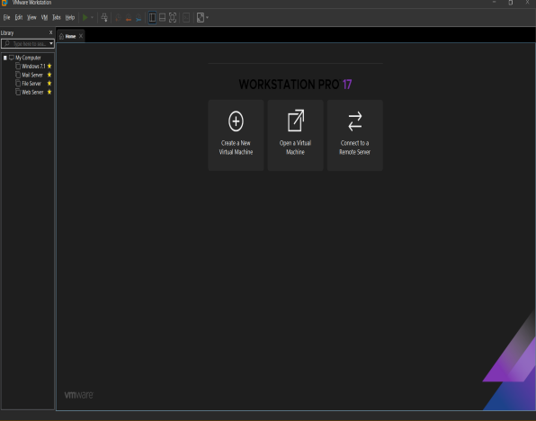

*Figure 1: A screenshot of the VMs installed*

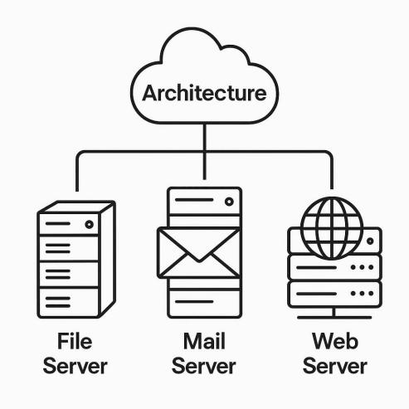

*Figure 2: A Network Diagram for the Virtual Environment*

# **Step-by-step Configuration Process.**

## **Installation of the Virtualization Platform and a Base OS.**

### **Installing VMware Workstation**

**Step1:** Get the **Installer (VMware Workstation 17.6.3)**.

**Step 2:** Run the **Installer** and follow the **on-screen instructions** and **restart the PC** after installation.

**Step 3:** Lauch **VMware Workstation 17.6.3**.

**Step 4:** Create a **New Virtual Machine** and Select **Custom (advanced) Configuration**.

**Step 5:** Select the **Windows Server 2012 R2 ISO file** as installation media.

**Step 6:** Specify the virtual machine’s name **(Web Server)** and location.

**Step 7:** Allocate **RAM as 2048mb** and **CPU as 2** and **Disk Space as 50gb** to the Server.

**Step 8:** Configure **Network Settings** and Finish the creation process.

### **Installing Windows Server 2012 R2**

**Step 9:** Power on the newly created virtual machine.

**Step 10:** Select the **Image Disk**, In this case **Window Server 2012 R2 Standard**.

**Step 11:** Follow on-screen instructions to install **Window Server 2012 R2 Standard.**

**Step 12:** Select **Custom (advanced) Configuration** and Create **Partitions** on the virtual hard drive if needed.

**Step 13:** Log in to **Windows Server 2012 R2** and configure the initial setting.

## **Creating and configuring the virtual machines**

### **Cloning Process**

**Step 1:** Highlight the Virtual Machine **(Web Server).**

**Step 2:** **Right-click** and Select **Manage** then **Clone.**

**Step 3:** From the **Clone Wizard**, select **Full Clone**.

**Step 5:** Click on **Finish** to start cloning process.

**Step 6:** Once cloning is done, **Power On** the cloned virtual machine.

**Step 7**: Repeat the same process to create the **Mail Server.**

### **Setting Up Internal Networking and Connectivity.**

**Configuring the Virtual Network in VMware.**

**Step 1: On the VMware Workstation, click on Edit > Virtual Network Editor.**

**Step 2: On the Wizard, Click on Add Network.**

**Step 3: Select an VMnet1 and click on OK >Choose Host-only.**

**Setting Network Adapter for all VMs**

**Step 4: Set Subnet IP (192.268.79.0) and Subnet (255.255.255.0).**

**Step 5: Select any VM, right-click and go to Settings > Network Adapter > Custom and select VMnet1 and ensure the Connect at power on checkbox is checked.**

**Step 6: Repeat Step 4 and Step 5 fot the other VMs.**

**Assigning Static IP Address to each VM**

**Step 7: Power On all VMs**

**Step 8: Open Control Panel > System and Security > Ethernet0 > Internet Protocol Version 4 (TCP/IPv4) > Properties.**

**Step 9: Input IP address, Subnet Mask and Default Gateway and click OK.**

## **Configuring the Services for the Servers.**

* **Web Server**

**Step 1**: Open **Server Manager,** and Select **Add roles and Features.**

**Step 2:** Select **Role-based Installation or Feature based** from **Installation. Type** and Select Server from the server pool.

**Step 3:** Install **IIS Manager** and **DNS Server**

**Step 3:** Open the **IIS server**, Click on **Site** then **Add Website**.

**Step 4:** Fill in the required credentials.

* **File server**

**Step 1:** **Step 1**: Open **Server Manager,** and Select **Add roles and Features.**

**Step 2:** Select **Role-based Installation or Feature based** from **Installation Type** and Select Server from the server pool.

**Step 3:** Click on **IIS Web Server**, Select **FTP Server**, Click on **Next** then **Install.**

**Step 4:** Open on **Tools**, Right click and select **IIS Manager.**

**Step 5:** Right-click on **Site** and **select Add FTP Site**

**Step 7**: Fill all required pop ups and select **basic authentications** for all devices connected to the server.

**Step 8**: Enable permission to **Read and Write**.

* **Mail Server**

**Step 1:** **Step 1**: Open **Server Manager,** and Select **Add roles and Features.**

**Step 2:** Select **Role-based Installation or Feature based** from **Installation Type** and Select Server from the server pool.

**Step 3**: Click on **IIS Web Server** on **Roles** then Click on **Next.**

**Step 4:** Select **SMTP Server** from **Features** then **Install.**

**Step 5:** From **Tools,** Open the **IIS 6.0 Manager.**

**Step 6**: Right-click on SMTP Virtual Server and Click of Properties.

**Step 7**: From the drop-down menu, Select IP Address and Enable logging then Apply.

**Step 8**: Click on **Access** > **Connection** > **Only the list below** and **Add**.

**Step 9**: Enter the **Local IP Address** of the computer you want to grant access to and Click on **Ok.**

**Step 10**: Click on **Delivery** > **Advanced** > Enter **fully qualified domain name** and Click on **OK** and **Apply** and Click on **Ok** again.

**Step 11**: Open **Windows Firewall Advanced Security**.

**Step 12**: Right-click on **Outbound Rules** > **New Rule** > **Port** > **Next**.

**Step 13**: Enter **25** as the **Specific Remote Ports** then Click on **Next**.

**Step 14**: Select **Allow Connection** > **Next** then **Next** again.

**Step 15**: **Enter Name (SMTP_inbound)** and Click on **Finish**.

**Step 16**: Go to **Control Panel** > **Administrative Tools** > **Services** > **Simple Mail Transfer Protocol.**

**Step 17**: Click on the **drop-down button** at **Startup type** and Select **Automatic** then **Apply** then **OK**.

**Step 18**: **Restart** Server.

# **Tools and Resources Used**

* VMware Workstation 17.6.3
* Windows Server 2012 R2
* PowerShell
* Telnet
* Internet Information Services
* FTP Server and SMTP Server
* Networking Tools

# **Testing and Validation**

* **Connectivity Testing:**

Using **ping** command to verify network connectivity between **VMs**.

* **Mail Server Functionality Testing:**

Using **Telnet** to connect to the **Mail Server** to confirm functionality of the **Mail Server**.

* **Web Server Functionality Testing:**

Opening a **web browser** and entering the **IP address** of the **Web Server** to validate correct hosting of website.

* **File Server Functionality Testing:**

Using **FTP Client** to connect to the **File Server** using the server’s **IP address** to ensure accessibility and functionality.

# **Challenges and Resolutions**

**Challenges**

1. **Connectivity Issues:**

Some virtual machines were unable to communicate with the mail server.

1. **SMTP Configuration Errors:**

Incorrect SMTP settings prevented emails from being sent.

**Resolutions**

* Verified the network adapter settings for each VM and ensured they were configured to the correct virtual network.
* Checked firewall settings to allow traffic between VMs.
* Reviewed and corrected the SMTP server settings in the IIS 6.0 Manager.
* Ensured the correct port (25) was open and accessible.
* Installed and Tested SMTP connections

# **Conclusion**

The implementation of a virtualized server environment at Kwame IT Solutions will significantly optimize the organization's IT infrastructure. By using VMware Workstation to create dedicated virtual servers for web, file, and mail services, the company will effectively address challenges related to high operational costs and inefficient resource utilization.

The virtualization process has led to reduced hardware expenses and energy consumption, enabling better financial resource allocation. Additionally, the improved scalability and performance of the servers enhance overall service delivery. Centralized management has streamlined maintenance and updates, minimizing downtime and administrative burdens.

As the organization continues to grow, ongoing monitoring and optimization of the virtual environment will be crucial. Regular assessments of performance, security updates, and exploring advanced virtualization technologies will help Kwame IT Solutions remain competitive and efficient. Overall, this project has not only resolved immediate issues but has also set the stage for future growth and innovation.

# **References**

How to Install and Configure SMTP Server, <https://youtu.be/Ver6k4rxybg?si=Tp8HLJ-msHLC5IPH>

How to Install and Configure a Web Server, <https://youtu.be/hIgjXlu6fuw?si=jY9eezJ_ztPkPg75>

How to Install Windows Server 2012 R2 on VMware. <https://www.google.com/url?sa=t&rct=j&q=&esrc=s&source=web&cd=&cad=rja&uact=8&ved=2ahUKEwiticrtq5SOAxXHWEEAHd6lKMcQtwJ6BAgPEAI&url=https%3A%2F%2Fwww.youtube.com%2Fwatch%3Fv%3DT_845jjG8BI&usg=AOvVaw1a4ulCzxsXAwG3zs1HHhAL&opi=89978449>

How to Install and Configure SMTP Server on Windows, <https://phoenixnap.com/kb/windows-smtp-server>

VMware WorkStation 17.6.3 Download, <https://www.google.com/url?sa=t&rct=j&q=&esrc=s&source=web&cd=&cad=rja&uact=8&ved=2ahUKEwiw6JGqrZSOAxU-YEEAHdmOFlQQFnoECAoQAQ&url=https%3A%2F%2Fwww.techspot.com%2Fdownloads%2F189-vmware-workstation-for-windows.html&usg=AOvVaw0bzve1PkkEr_dsPEDfn-3L&opi=89978449>